A mosaic of locomotory and sensory trait allocation across alternative mating strategies in Wellington tree wētā
Clint D. Kelly^{1,✉}
¹ Département des Sciences biologiques, Université du Québec à Montréal, Montréal, Canada
✉ Correspondence: Clint D. Kelly <kelly.clint@uqam.ca>

1. Introduction
Alternative mating strategies allow males to achieve reproductive success through divergent solutions to competition for mates. In many species, large or well-armed males defend females or reproductive resources, whereas smaller males avoid direct contests and obtain matings through sneaking, satellite behaviour or active searching (Gross 1996; Shuster and Wade 2003; Oliveira, Taborsky, and Brockmann 2008). These strategies are frequently associated with conspicuous differences in body size and weaponry, but alternative male phenotypes can differ in many additional aspects of morphology, physiology, behaviour and life history. They are therefore better understood as integrated phenotypes than as otherwise similar males differing only in the exaggerated trait used to classify them (West-Eberhard 2003). Selection should favour coordinated combinations of traits that facilitate the behaviour and ecological circumstances associated with each strategy.
Such phenotypic integration may arise because the development of one structure affects the resources available to others or because selection favours the coordinated expression of functionally complementary traits. Exaggerated sexually selected structures can impose developmental or performance costs that are mitigated by corresponding changes in supporting structures—a process termed secondary sexual trait compensation (Tomkins, Kotiaho, and Lebas 2005; Husak and Swallow 2011). Alternatively, investment in an exaggerated structure may occur at the expense of other traits when their development competes for a limited pool of resources (Nijhout and Emlen 1998; Emlen 2001; Moczek and Nijhout 2004). A third possibility is that investment in weapons and investment in supporting structures are positively integrated, such that individuals or morphs with larger weapons also invest more in locomotory and sensory traits—an outcome expected when overall phenotypic quality or developmental resources simultaneously elevate multiple traits (Bonduriansky and Day 2003; Tomkins, Kotiaho, and Lebas 2005). These processes need not be uniform among male morphs. Developmental switches underlying alternative phenotypes can alter the covariance among traits, producing morph-specific patterns of integration even though the morphs possess the same basic anatomical structures (Snell-Rood et al. 2010; Rohner, Macagno, and Moczek 2020).
Most work on morph-specific integration has focused on weapons and the structures that support their use. In horned dung beetles, for example, horn length is positively integrated with fore- and hindleg morphology, and this integration can be stronger in major than in minor males (Tomkins, Kotiaho, and Lebas 2005; Rohner, Macagno, and Moczek 2020), consistent with positive co-expression of weapons and supporting structures in the conventional morph. Similarly, male rhinoceros beetles with relatively long horns also have relatively long wings and foretibiae, potentially improving locomotion and leverage during combat, although horn size is unrelated to eye size after accounting for body size (McCullough and Emlen 2013). By contrast, in the male-dimorphic stag beetle Prosopocoilus inclinatus, weapon size is integrated with eye size in major males but with foreleg length in minor males (Ito, Ohkubo, and Hasegawa 2017), suggesting that the traits co-expressed with weaponry can differ between morphs rather than being uniformly larger in the morph with the largest weapons. These findings show that weapon exaggeration can be accompanied by coordinated changes in other traits, but that the pattern and direction of integration need not be predictable from weapon size alone.
Locomotor and sensory traits should be especially relevant to alternative mating strategies because males must both locate mating opportunities and gain access to them. The spatial distribution of receptive females can generate a fundamental contrast between remaining with and defending current mates and searching for additional mates (Shuster and Wade 2003). Males that patrol widely or move among defended mating sites may consequently benefit from locomotor structures that enhance movement, whereas males that defend females may benefit from appendages that provide support or leverage during combat. Sensory demands may also differ among strategies, though the direction of morph differences is not predetermined. In the desert bee Centris pallida, small males rely primarily on vision for mate detection while large males use chemosensory cues; correspondingly, small males possess relatively larger eyes despite their smaller body size (Meghan Barrett et al. 2021; M. Barrett and O’Donnell 2026), consistent with enhanced sensory investment in the morph that actively searches for mates. However, if conventional males require accurate sensory assessment of rivals or of gallery quality to defend harems effectively, the direction of morph differences in sensory investment could be reversed. Few studies have examined locomotor and sensory traits together within a single species to determine whether such differences represent coordinated phenotypic divergence or trait-specific responses to the demands of each strategy.
The Wellington tree wētā, Hemideina crassidens, provides an opportunity to address this question. This flightless, nocturnal orthopteran is harem-polygynous, and females shelter communally in cavities in trees, hereafter galleries. Males use their enlarged heads and mandibles as weapons in contests for control of female-occupied galleries, and males with larger weapons generally have an advantage during escalated fights (Kelly 2005, 2006; Kelly and Adams 2010). Males express three genetically polymorphic, irreversible morphotypes through maturation at the eighth, ninth or tenth juvenile instar (Nason and Kelly 2020; Kelly 2024). Large tenth-instar males possess the most exaggerated weaponry and commonly fight for control of galleries. Small eighth-instar males possess much smaller weapons and may circumvent larger defenders to obtain copulations or search vegetation for undefended females, whereas ninth-instar males exhibit an intermediate strategy that combines fighting and sneaking depending on the social context (Wilson and Kelly 2019; Kelly 2025). The three strategies attain similar average reproductive fitness, consistent with their maintenance as a balanced polymorphism (Nason and Kelly 2020).
Here, I tested whether these alternative male morphotypes differ in the relative expression and allometric scaling of locomotor and sensory traits. I measured the lengths of the fore-, mid- and hindlegs as indices of locomotor morphology, and I measured eye size and the area of the tympanal ears on the foretibiae as indices of visual and auditory investment. Females were included as a non-morphotypic reference group that shares the species’ general locomotor and sensory requirements but does not use enlarged mandibles in competition for mates. I asked whether the three leg pairs show a common pattern of allocation among groups or whether particular groups disproportionately invest in specific legs, and whether any anterior-posterior shift in allocation accompanies strategy divergence. I also tested whether weapon size is positively integrated with, negatively associated with, or independent of locomotory and sensory investment within groups—a comparison that directly distinguishes positive integration from resource trade-offs and developmental decoupling.
To my knowledge, this study is the first to examine locomotory and sensory morphology jointly across females and every male morphotype in a trimorphic insect expressing genetically polymorphic alternative mating strategies. Previous studies have generally considered a limited set of weapon-associated traits, often in male-dimorphic systems, and have rarely combined body-size-adjusted comparisons with analyses of allometric scaling and within-morph covariance. By integrating body-size-adjusted trait comparisons, group-specific allometry, anterior–posterior leg allocation, local anatomical integration and within-group weapon–trait covariance, my framework distinguishes morphological divergence among strategies from developmental integration within them. Because morph identity in H. crassidens is genetically polymorphic rather than induced by nutritional condition, comparisons among morphs are also less confounded by condition-dependent morph expression than in many polyphenic systems. This multilevel approach allows me to test whether alternative strategies represent broadly coordinated phenotypes or mosaics of trait-specific modification.
Two competing outcomes are possible. Under a searching and detection hypothesis, eighth-instar males—which locate mates by patrolling vegetation and circumventing gallery defenders—should face greater locomotory and sensory demands than their gallery-defending counterparts. If morphology tracks these demands, eighth-instar males should possess relatively longer legs and larger sensory structures at a common body size, and weapon size within groups should be decoupled from or negatively associated with locomotory and sensory investment. Under a positive-integration hypothesis, the morphotypic differences in weapon size reflect broader variation in developmental resources or overall phenotypic quality, such that conventional tenth-instar males simultaneously express larger weapons, longer legs, and greater sensory investment. On this view, weapon size within groups should be positively integrated with supporting structures regardless of morph identity. These two hypotheses generate opposite predictions for which morph leads in relative locomotory and sensory investment, and for the sign of within-group weapon–trait covariance. Ninth-instar males were expected to be intermediate or more generalized, consistent with their flexible combination of fighting and sneaking. More broadly, group-specific allometric slopes would indicate that trait expression scales differently with body size among morphotypes, whereas differences in elevation with common slopes would indicate proportional shifts in relative investment. By testing these predictions simultaneously across locomotory and sensory traits, I ask whether the alternative mating strategies of H. crassidens are expressed as broadly integrated phenotypes or as a mosaic of trait-specific adjustments.

2. Methods

2.1 Study site and specimen collection
Adult Wellington tree wētā, Hemideina crassidens, were haphazardly collected at night from vegetation on Te Pākeka/Maud Island, New Zealand (41°02′ S, 173°54′ E), during March and April of 2011 ($n=74$), 2015 ($n=123$) and 2016 ($n=107$). Te Pākeka/Maud Island is a 309-ha scientific reserve in the Marlborough Sounds that is free of introduced mammalian predators. The sample collected in each year included females and males representing each of the three adult male morphotypes.
Adult males were assigned to eighth-, ninth- or tenth-instar morphotypes from their head lengths following Kelly and Adams (2010) and Kelly (2026). The later parameters were derived from a trimodal mixture model of male head length (Kelly 2026).
Following collection, individuals were euthanized by freezing at −20 °C. Each specimen was subsequently dissected to remove the head, pronotum, both forelegs, both midlegs and both hindlegs. All structures dissected from an individual were placed together in a labelled screw-cap tube to preserve their association with the individual’s unique identifier.

2.2 Digital imaging and morphological measurements
Specimens were transported to the Université du Québec à Montréal, where each dissected structure was photographed separately using a Canon EOS 5D Mark IV digital camera fitted with a Canon EF 100 mm f/2.8L IS USM Macro lens and Canon MT-26EX-RT macro flashes. The camera was mounted on a copy stand approximately 40 cm above the specimen, with the camera sensor parallel to the imaging surface. Each specimen was photographed with its identifier and a ruler positioned in the same plane. Images were calibrated from the ruler, and a visible 5-mm scale bar was added using ImageJ.
Morphological measurements were obtained from the calibrated images using Fiji (Schindelin et al. 2012). All linear traits were measured using the straight-line tool, with measurement endpoints defined by consistent anatomical landmarks illustrated in Figure 1. Ear area was measured by tracing the perimeter of the tympanal membrane using the freehand selection tool.
The measured linear traits were pronotum length, head length, head width, eye length, and the femur and tibia lengths of the forelegs, midlegs and hindlegs. Left and right structures were measured independently for bilateral traits, and the mean of the two sides was used in the analyses. Total foreleg, midleg and hindleg lengths were calculated as the sum of the corresponding femur and tibia lengths.

2.3 Measurement repeatability
Measurement repeatability was assessed using 48 individuals selected by stratified random sampling. Four individuals were selected from each of the 12 combinations of collection year and sex or morph group: females and eighth-, ninth- and tenth-instar males in each of the three collection years. Every trait was remeasured twice from the original images, yielding three measurements per trait when the original measurement was included. Image order was randomized independently for each measurement round, and previous measurements were not consulted during remeasurement.
Repeatability was estimated separately for each trait using Gaussian linear mixed-effects models with individual identity as a random intercept. The primary, pooled model contained no fixed effects, and the intraclass correlation coefficient was calculated as the proportion of total variance attributable to differences among individuals:
$$R=\frac{V_{individual}}{V_{individual}+V_{residual}}.$$
Repeatability models and bootstrap confidence intervals were fitted using rptR (Stoffel, Nakagawa, and Schielzeth 2017). Ninety-five per cent confidence intervals were obtained from 1,000 parametric bootstrap replicates. Because females and the three male morphs differ substantially in mean morphology, each analysis was repeated with morph included as a fixed effect. These adjusted estimates quantify repeatability among individuals after removing average differences among morphs. A further model included both morph and measurement round as fixed effects to estimate consistency after accounting for systematic session differences.
Systematic differences among measurement sessions were tested using a linear mixed-effects model containing measurement round as a three-level fixed effect and individual identity as a random intercept. Omnibus round-effect p-values were adjusted across the 11 traits using both Benjamini–Hochberg and Holm procedures, with the more conservative Holm-adjusted results used in the text. Pairwise bias was calculated as the mean within-individual difference between a later and an earlier round. Pairwise technical error of measurement was calculated as $\sqrt{∑d_{i}^{2}/\left(2n\right)}$, where $d_{i}$ is the within-individual difference. Overall technical error across the three rounds was the pooled within-individual standard deviation, and relative technical error was calculated as 100 times the technical error divided by the trait mean. Absolute agreement was also summarized using the two-way, single-measure ICC(A,1) among individuals with complete measurements in all three rounds. To test for drift within remeasurement sessions, signed and absolute deviations from the original measurement were regressed on randomized measurement position; these p-values were Benjamini–Hochberg adjusted separately for signed and absolute deviations.

2.4 Statistical analysis
All analyses were conducted in R (R Core Team 2025). Data preparation and visualization were performed using the tidyverse (Wickham et al. 2019). Ordinary least-squares models were fitted using base R. Linear mixed-effects models were fitted using lme4 (Bates et al. 2015) and lmerTest (Kuznetsova, Brockhoff, and Christensen 2017). Estimated marginal means, allometric trends and contrasts were calculated using emmeans (Lenth et al. 2019), with Kenward–Roger approximations supported by pbkrtest (Halekoh and Højsgaard 2014). Model diagnostics and graphical checks were produced using performance (Lüdecke, Ben-Shachar, et al. 2021), see (Lüdecke, Patil, et al. 2021) and broom (Robinson 2014). The R version and package versions used in the analysis were recorded using sessionInfo().
Females and eighth-, ninth- and tenth-instar males were represented by the four levels of a categorical variable termed group. Pronotum length was used as the measure of structural body size. Composite head size was calculated as the geometric mean of head length and head width:
$$head size=\sqrt{head length×head width}.$$
Because ear size was measured as an area, its square root was taken to express it as a linear dimension before analysis. All continuous morphological variables were then transformed using natural logarithms. Allometric slopes from these log–log models can therefore be interpreted as allometric exponents.
Log pronotum length was centred on a pronotum length of 7.2 mm:
$$logP_{c}=log\left(pronotum\right)−log\left(7.2\right).$$
This reference value lay within the range of pronotum lengths shared by all four groups. Model intercepts and estimated marginal means at $logP_{c}=0$ therefore describe individuals with a pronotum length of 7.2 mm and represent interpolation rather than extrapolation.
Before fitting the models, the data were checked for duplicate individual identifiers, unexpected sex or morph labels, missing observations, nonpositive measurements and implausible measurement ranges. Missing observations were excluded separately for each model, and sample sizes could therefore differ among analyses.

2.4.1 Leg allometry
Allometric relationships for the forelegs, midlegs and hindlegs were initially examined separately using ordinary least-squares models. For each leg pair, a common-slope model,
$$log\left(leg length\right)∼logP_{c}+group,$$
was compared with a model allowing group-specific slopes,
$$log\left(leg length\right)∼logP_{c}×group.$$
Partial $F$-tests comparing the nested models were used to determine whether allometric slopes differed among groups. Group-specific allometric slopes and pairwise differences among slopes were estimated using emtrends().
The primary test of relative locomotory allocation used a repeated-trait linear mixed-effects model. Foreleg, midleg and hindleg measurements were arranged in long format so that each individual contributed as many as three observations. Log leg length was modelled as
$$log\left(leg length\right)∼logP_{c}×group×leg+\left(1|individual\right).$$
Individual identity was included as a random intercept to account for the nonindependence of the three leg measurements from the same specimen. The model was fitted by maximum likelihood. Fixed effects were evaluated using type III tests with Satterthwaite approximations to the denominator degrees of freedom. The three-way interaction tested whether group differences in allometric slope depended on leg identity.
Estimated marginal means were calculated separately for each leg pair at a pronotum length of 7.2 mm. Because the response variables were log transformed, adjusted means were exponentiated and are reported on the original scale as geometric means. Contrasts were also exponentiated and are reported as ratios, with values greater than one indicating that the first group named in the contrast had the larger predicted trait.
All pairwise group comparisons were calculated within each leg pair. Three biologically motivated contrasts were also evaluated:
- eighth-instar versus tenth-instar males;
- ninth-instar males versus the midpoint of eighth- and tenth-instar males; and
- tenth-instar males versus females.
Additional difference-in-differences contrasts tested whether group differences varied between the foreleg and hindleg, between the midleg and hindleg, and between the mean of the two anterior leg pairs and the hindleg. These contrasts tested differences in relative anterior–posterior allocation rather than differences in absolute leg length alone.
As secondary analyses, each total-leg pattern was decomposed into its femur and tibia components. Common- and group-specific allometric models were fitted separately to the forefemur, foretibia, midfemur, midtibia, hindfemur and hindtibia. Nested-model $F$-tests were used to test for group differences in slope, and group-specific slopes were estimated using emtrends().

2.4.2 Relative head and foretibia size
Relative head size was estimated using residuals from a group-specific allometric model:
$$log\left(head size\right)∼logP_{c}×group.$$
The residual for an individual indicates whether its head was larger or smaller than expected for its pronotum size and group. Relative foretibia size was calculated analogously from the model
$$log\left(foretibia\right)∼logP_{c}×group.$$
These residual indices separate within-group variation in relative trait size from the large differences in absolute morphology among females and the three male morphotypes.

2.4.3 Head–leg integration and secondary sexual trait compensation
The secondary sexual trait compensation hypothesis predicts that individuals possessing relatively large heads or weapons should also possess relatively large supporting structures. This prediction was tested by extending the joint leg model to include relative head size:
$$log\left(leg length\right)∼logP_{c}×group×leg+relative head size×group×leg+\left(1∣individual\right).$$
Group- and leg-specific slopes relating leg length to relative head size were estimated using emtrends(). Slopes were compared among groups within each leg pair and among leg pairs within each group. A positive slope was interpreted as phenotypic integration consistent with secondary sexual trait compensation, a negative slope as evidence of a morphological trade-off, and a slope close to zero as evidence of developmental decoupling.

2.4.4 Body-size-adjusted sensory investment
Group differences in ear and eye investment were examined at a common structural body size. Log linearized ear size and log eye length were each modelled as functions of log pronotum length, group and their interaction:
$$log\left(sensory trait\right)∼logP_{c}×group.$$
For each sensory trait, a common-slope model was compared with the group-specific-slope model using a nested-model $F$-test. Group-specific allometric slopes were estimated using emtrends(), and estimated marginal means were calculated at a pronotum length of 7.2 mm.
Eye estimates were exponentiated to return them to the original length scale. For the ear, estimated marginal means on the log-linearized scale were transformed back to the original area scale as
$$\hat{ear area}=exp\left(2\hat{μ}\right),$$
where $\hat{μ}$ is the predicted log linearized ear size. Contrasts in linearized ear size were squared after exponentiation to obtain ratios on the area scale.

2.4.5 Local sensory integration
Local integration of the ear with the foretibia was tested using relative foretibia size. The full model was
$$log\left(linearized ear size\right)∼logP_{c}×group+relative foretibia size×group.$$
This model tested whether individuals having a larger foretibia than expected for their body size and group also had a relatively larger ear. A reduced model containing a common relative-foretibia slope was compared with the full model using a nested-model $F$-test.
Eye–head integration was tested using the corresponding model
$$log\left(eye length\right)∼logP_{c}×group+relative head size×group.$$
A positive relationship between eye length and relative head size was interpreted as developmental integration, a negative relationship as evidence of a head–eye trade-off, and a relationship close to zero as evidence of developmental decoupling.
An additional model tested direct covariance between weapon and ear investment:
$$log\left(linearized ear size\right)∼logP_{c}×group+relative head size×group.$$
A negative slope was considered consistent with a weapon–sensory trade-off, whereas a positive slope indicated phenotypic integration and a slope close to zero indicated developmental decoupling.

2.4.6 Contrasts and statistical inference
Estimated marginal means and trends are presented with 95% confidence intervals. Kenward–Roger approximations were used for degrees of freedom associated with mixed-model estimated marginal means and contrasts. Pairwise and planned contrasts were corrected using Holm’s sequential procedure within each defined family of tests. Statistical significance was evaluated at α = 0.05, but interpretation also considered estimated effect sizes, confidence intervals and the biological direction of each relationship.

2.4.7 Model diagnostics
Model assumptions were evaluated using graphical checks of residual normality, homogeneity of variance and relationships between residuals and fitted values. Multicollinearity was assessed using variance-inflation diagnostics. Observations were flagged for further inspection when Cook’s distance exceeded $4/n$, leverage exceeded $2p/n$, or the absolute standardized residual exceeded 3, where $n$ was the model sample size and $p$ was the number of estimated coefficients. These thresholds were used only as diagnostic screening criteria and did not result in the automatic deletion of observations.

3. Results

3.1 Measurement repeatability
Repeatability was high for all 11 traits. Pooled estimates ranged from $R=0.976$ for ear area (95% CI 0.961–0.986) to $R=0.9997$ for head length (95% CI 0.9995–0.9998). Estimates remained high after morph was included as a fixed effect ($R=0.949$–$0.996$); ear area again had the lowest estimate ($R=0.949$, 95% CI 0.916–0.969). The high pooled estimates therefore did not depend only on the large mean differences among females and the three male morphs.
A measurement-round effect remained supported after Holm adjustment for 8 traits: pronotum length, head length, head width, foretibia length, ear area, midfemur length, hindfemur length and hindtibia length (all Holm-adjusted $p≤0.039$). The shifts were small in magnitude. Overall relative technical error ranged from 0.48% to 2.57%, and absolute-agreement ICC(A,1) values ranged from 0.9765 to 0.9997. The largest pairwise bias was 2.154% for ear area; the maximum absolute bias for every other trait was no greater than 1.085%. Randomized measurement position was unrelated to either signed error (minimum Benjamini–Hochberg-adjusted $p=0.524$) or absolute error (minimum adjusted $p=0.867$). Thus, several traits showed slight session-specific shifts, but measurement error was small and absolute agreement remained high across rounds.

3.2 Sample composition and body-size overlap
The analysis included 313 individuals: 118 females, 78 eighth-instar males, 79 ninth-instar males, and 38 tenth-instar males. Mean pronotum length was 7.81 ± 0.41 mm in females, 6.37 ± 0.37 mm in eighth-instar males, 6.93 ± 0.32 mm in ninth-instar males, and 7.52 ± 0.31 mm in tenth-instar males. All four groups overlapped in pronotum length from 6.99 to 7.49 mm. The reference pronotum of 7.2 mm used for size-adjusted comparisons therefore lay within the region of common support.

3.3 Locomotory morphology

3.3.1 Relative allocation among leg pairs
The joint repeated-trait model showed that group differences depended strongly on leg identity (F(6, 622.86) = 100.35, p < 0.001). The male developmental groups were therefore not uniformly longer- or shorter-legged than females; the magnitude and direction of group differences varied among foreleg, midleg, and hindleg pairs. There was also evidence that group-specific allometric slopes depended on leg identity (F(6, 622.72) = 2.18, p = 0.044), although this three-way effect was much weaker than the group-by-leg interaction. The body-size-by-group interaction was also supported within the joint model (F(3, 312.31) = 3.62, p = 0.013).
At a pronotum length of 7.2 mm, eighth-, ninth-, and tenth-instar males had forelegs that were 5.8% longer (Holm-adjusted p < 0.001), 11.4% longer (Holm-adjusted p < 0.001), and 16.9% longer (Holm-adjusted p < 0.001), respectively, than those of females. Midlegs were 2.1% longer (Holm-adjusted p = 0.057), 7.5% longer (Holm-adjusted p < 0.001), and 12.2% longer (Holm-adjusted p < 0.001), respectively. Hindlegs showed a contrasting pattern: eighth-instar males had hindlegs that were 6.3% shorter (Holm-adjusted p < 0.001), ninth-instar males had hindlegs that were 0.5% shorter (Holm-adjusted p = 0.555), and tenth-instar males had hindlegs that were 3.9% longer (Holm-adjusted p < 0.001) relative to females. Overall, foreleg enlargement escalated most strongly at the terminal instar, whereas hindleg morphology followed a shallower trajectory (see below).
The planned strategy contrasts revealed a consistent size gradient among the male morphs. Across all three leg pairs, tenth-instar males had significantly longer legs than eighth-instar males (foreleg: 9.5% shorter in eighth-instar males, Holm-adjusted p < 0.001; hindleg: 9.9% shorter, Holm-adjusted p < 0.001), while ninth-instar males were statistically indistinguishable from the midpoint of the eighth- and tenth-instar means (foreleg intermediacy contrast: p = 0.901), consistent with their jack-of-all-trades strategy.
The anterior-posterior allocation analysis tested whether group differences were disproportionate across leg pairs. Among the three male morphs, allocation differences between eighth- and tenth-instar males and between ninth-instar males and the male midpoint were negligible (all Holm-adjusted p ≥ 0.975). However, tenth-instar males showed a significant anterior shift in allocation relative to females: the foreleg-to-hindleg ratio in tenth-instar males exceeded that of females by 12.5% (ratio of ratios = 1.13, Holm-adjusted p < 0.001), and a comparable pattern was found for all three anterior-posterior allocation contrasts (all Holm-adjusted p ≤ 0.000). This indicates that the locomotory morphology of tenth-instar conventional males is disproportionately weighted toward the anterior leg pairs relative to females.

3.3.2 Allometric variation
Estimated allometric slopes were below one for all group-by-leg combinations, indicating negative allometry of leg length relative to pronotum length throughout. Tenth-instar males had the shallowest estimated slopes across all three leg pairs. After Holm correction within each leg, the clearest specific contrast was the hindleg slope difference between females and tenth-instar males (difference = 0.537, p = 0.003). The exhaustive decomposition of the three-way interaction further showed that the female–eighth-instar slope contrast differed between forelegs and hindlegs (difference-in-differences = -0.193, p = 0.048), meaning that females and eighth-instar males had nearly parallel foreleg allometries whereas their hindleg allometries were more divergent. Other corrected slope contrasts were not clearly supported.

3.3.3 Femur and tibia components
Group-specific allometric slopes were supported for Forefemur, Midfemur, Hindfemur, Hindtibia; the remaining segment models were adequately described by common slopes. These secondary analyses indicate which femur or tibia segments contributed to the group-level differences in total leg allometry.

3.4 Weapon–leg integration
To test whether relative weapon investment was positively integrated with leg size across groups—as predicted if weapon and locomotory traits are co-expressed rather than traded off—I extended the joint leg model to include relative head size (weapon size adjusted for pronotum length) as an additional covariate. The association was consistently positive: 11 of 12 group-by-leg combinations had 95% confidence intervals entirely above zero, and no estimated slope was negative. The three-way interaction of group, leg, and relative head size was significant (F(6, 623.0) = 5.22, p < 0.001), indicating that the magnitude of weapon–leg integration varied across leg pairs and groups. The planned strategy slope contrasts, however, were uniformly non-significant after Holm adjustment, meaning that no morph showed a weapon–leg integration profile that clearly differed from the others in the planned comparisons. Taken together, these results are consistent with positive phenotypic integration between weapon and leg investment, with no evidence of a negative trade-off.

3.5 Sensory morphology

3.5.1 Group differences at a common body size
Ear size (tympanic organ area) and eye length both differed significantly among groups at a common pronotum length. Allometric slopes for ear size on pronotum length did not differ among groups (F(3, 305) = 0.25, p = 0.862), nor did those for eye length (F(3, 305) = 0.63, p = 0.596), justifying a common-slope model for body-size adjustment in both cases.
At a pronotum length of 7.2 mm, tenth-instar males had tympanic organ areas that were 16.1% larger in area than females (Holm-adjusted p < 0.001), while eighth-instar males had areas 13.2% smaller than tenth-instar males (Holm-adjusted p < 0.001). The ninth-instar intermediacy contrast was not significant (p = 0.514). Eye length showed a larger and more pronounced gradient: tenth-instar males had eyes 27.0% longer than females (Holm-adjusted p < 0.001), while eighth-instar males had eyes 13.4% shorter than tenth-instar males (Holm-adjusted p < 0.001). Again, ninth-instar males were statistically intermediate (p = 0.293). In both sensory traits, the morph gradient—from eighth-instar to tenth-instar—paralleled the weapon-size gradient, with conventional tenth-instar males investing most in both sensory structures and sneak-mating eighth-instar males investing least.

3.5.2 Local morphological integration
I tested whether ear and eye size were locally integrated with the morphological structures they are most closely associated with—the foretibia (for the tympanic organ) and the head capsule (for compound eyes)—after removing group-specific body-size variation from both the sensory and predictor traits. Local integration slopes did not differ significantly among groups for either the ear–foretibia relationship (F(3, 301) = 1.33, p = 0.264) or the eye–head relationship (F(3, 301) = 1.97, p = 0.118). The 95% confidence interval was entirely above zero for 4 of 4 ear–foretibia slopes and 4 of 4 eye–head slopes, indicating broadly consistent local developmental coupling. The absence of supported group differences in these slopes suggests that the ear–foretibia and eye–head integration patterns are similar across the three mating strategies and females.
The positive eye-head slope deserves particular interpretive attention: because the head capsule is the same structure that bears the mandibular weaponry, weapon size and eye size are necessarily measured on the same structure. Individuals with proportionally larger heads will tend to have larger eyes partly as a geometric consequence of head capsule size, independently of any allocation decision. The eye-head integration slopes (0.40–0.94 across groups) should therefore be interpreted as reflecting structural rather than necessarily adaptive coupling between vision and weapon investment.

3.5.3 Weapon–sensory covariance
To directly test whether sensory investment was positively integrated with, traded off against, or decoupled from weapon investment, I regressed ear size on relative head size (weapon proxy, adjusted for body size) within each group. The group × weapon interaction for ear size was not significant (F(3, 301) = 1.34, p = 0.261), indicating a common relationship between weapon investment and ear investment across groups. The female weapon-ear slope was positive and clearly different from zero (0.397, 95% CI 0.178–0.615, p < 0.001). Among the three male morphs, however, weapon-ear slopes ranged from 0.130 to 0.291 and none was individually significant at α = 0.05 (all p ≥ 0.064). This pattern—positive covariance in females, near-zero covariance in males—is consistent with developmental decoupling of ear investment from weapon investment within male morphs. There was no evidence of a trade-off (negative slope) in any group.

3.6 Model diagnostics
Observed and model-predicted trait distributions corresponded closely. Residuals were approximately normally distributed and showed broadly homogeneous variance, with only minor curvature near the extremes of the fitted ranges. Collinearity remained below conventional concern thresholds, and no observation showed sufficient influence to justify exclusion after the underlying measurements had been checked. The log–log linear models and the repeated-trait mixed model were therefore retained for inference.

4. Discussion
Alternative mating strategies are expected to comprise coordinated combinations of traits that support different routes to reproductive success. My results provide qualified support for this view but show that morphological coordination in Wellington tree wētā is more complex than either of my original hypotheses predicted. The searching and detection hypothesis was not supported: at a common body size, eighth-instar males did not possess the longest legs or the largest sensory structures. Instead, relative leg length generally increased from eighth- to tenth-instar males, and the same morph gradient was especially clear for eye length and tympanic organ area. The positive-integration hypothesis received stronger support because weapon size covaried positively with leg length within nearly every group, with no evidence that exaggerated head size was associated with reduced locomotory morphology. However, this integration did not extend uniformly to sensory traits. Ear investment differed substantially among morphs but was only weakly related to relative weapon size within male morphs, while local ear–foretibia and eye–head integration was broadly conserved across groups. Alternative mating strategies in this species therefore appear to be expressed as a mosaic of trait-specific changes rather than as uniformly integrated whole-organism phenotypes.

4.1 Locomotory divergence among mating strategies
The three male morphs formed a consistent gradient in size-adjusted leg length, with tenth-instar males possessing the longest fore-, mid- and hindlegs and eighth-instar males the shortest. Ninth-instar males were generally intermediate and statistically indistinguishable from the midpoint between the two other male morphs. This morphological intermediacy is consistent with their proposed jack-of-all-trades strategy, in which males can either fight for galleries or circumvent larger competitors depending on the social context (Wilson and Kelly 2019; Kelly 2025). It does not, however, indicate that ninth-instar morphology is specifically adapted for behavioural flexibility. An intermediate phenotype could also arise directly from maturation at an intermediate instar. Functional tests are therefore needed to establish whether the morphological position of ninth-instar males enhances their ability to alternate between fighting and searching tactics.
Comparisons with females revealed a pattern that was not apparent from comparisons among male morphs alone. All male groups had relatively longer forelegs than females, whereas male–female differences in hindleg length varied from negative in eighth-instar males to positive in tenth-instar males. Consequently, tenth-instar males displayed a pronounced anterior shift in leg allocation relative to females. The anterior legs may contribute to stabilizing the body, maintaining purchase on the substrate or manoeuvring during encounters involving the head and mandibles. Such functions would make disproportionate anterior investment particularly valuable to heavily armed, gallery-defending males. Similar reasoning has been applied to the association between horns and foreleg morphology in dung and rhinoceros beetles, where the legs can provide leverage or support during contests (Tomkins, Kotiaho, and Lebas 2005; McCullough and Emlen 2013). Nevertheless, the present data describe morphology rather than mechanical performance, and the proposed role of anterior legs in combat remains to be tested directly.
The absence of comparable anterior–posterior allocation differences among the three male morphs is also informative. Eighth- and tenth-instar males differ markedly in weapon size and reproductive behaviour, yet they did not exhibit strongly divergent foreleg-to-hindleg allocation after body size was controlled. The primary locomotory distinction among male morphs was therefore a general gradient in the lengths of all three leg pairs rather than a major redistribution of investment from posterior to anterior appendages. A simple distinction between long-legged searching males and anteriorly specialized fighting males is consequently not supported. Instead, the clearest shift in relative leg allocation appears to separate heavily armed tenth-instar males from females, rather than separating conventional and unconventional males.
All leg traits scaled hypoallometrically with pronotum length, meaning that larger individuals within each group possessed proportionally shorter legs. Tenth-instar males generally had the shallowest estimated slopes, although support for specific slope differences was limited primarily to the hindleg comparison between females and tenth-instar males. Thus, the leg differences among groups were driven more consistently by changes in trait elevation at a common body size than by wholesale reprogramming of allometric slopes. This contrasts with weapon allometry in the same population, which differs substantially among male morphs, with eighth-instar weapons scaling more steeply than those of ninth- and tenth-instar males (Kelly 2026). Locomotory and weapon morphology therefore need not share the same morph-specific scaling rules, further supporting a modular or mosaic interpretation of morphological divergence.

4.2 Positive weapon–leg integration
Within groups, individuals possessing relatively larger heads generally also possessed relatively longer legs. Eleven of the 12 group-by-leg slopes were clearly positive, and none was negative. These results provide no evidence for the hypothesis that greater investment in weaponry is realized at the expense of locomotory appendages. Instead, they are consistent with positive phenotypic integration between weapons and structures that may support their use. This pattern resembles secondary sexual trait compensation, in which enlargement of a sexual trait is accompanied by enlargement of structures that bear, manoeuvre or otherwise improve the performance of that trait (Tomkins, Kotiaho, and Lebas 2005; Husak and Swallow 2011).
The present results also resemble those reported for the European earwig, another hemimetabolous insect in which male morphs differ in weapon size. Tomkins, Kotiaho, and Lebas (2005) found positive integration between forceps length and hind-femur length in exaggerated macrolabic males, but no evidence that forceps enlargement traded off against the other measured traits. They proposed that morphological trade-offs may be less readily expressed in hemimetabolous insects than in holometabolous taxa because growth is not confined to a closed pupal developmental system. Wellington tree wētā likewise acquire resources and grow through successive nymphal instars, and the uniformly non-negative weapon–leg relationships are consistent with that proposal. This comparison remains tentative, however, because the absence of a negative phenotypic correlation does not demonstrate the absence of an underlying allocation cost. Variation among individuals in resource acquisition can produce positive covariance among costly traits even when those traits compete for resources during development.
Unlike the morph-specific integration observed in European earwigs, the planned comparisons in Wellington tree wētā did not show that weapon–leg integration was consistently stronger in tenth-instar males than in the unconventional morphs. Although the overall group-by-leg-by-weapon interaction indicated heterogeneity among slopes, no planned morph contrast remained clearly supported after correction for multiple comparisons. The positive relationship may therefore reflect a shared developmental architecture linking head and appendage growth rather than a compensatory programme uniquely expressed by heavily armed males. Alternatively, similar slopes could be maintained by correlational selection in all groups because legs contribute to functions other than combat, including climbing, foraging, predator avoidance and mate searching. The evidence is consequently best described as positive phenotypic integration consistent with secondary sexual trait compensation, rather than as proof that longer legs evolved specifically to offset the mechanical costs of larger weapons.

4.3 Sensory divergence among morphs
Sensory morphology showed an especially clear morph gradient. At a common pronotum length, tenth-instar males had the largest eyes and tympanic organs, eighth-instar males had the smallest, and ninth-instar males were intermediate. This pattern is opposite to the prediction that the actively searching eighth-instar morph would invest most heavily in sensory structures used to locate mating opportunities. It also contrasts with the pattern in the desert bee Centris pallida, in which small searching males rely more strongly on visual detection and possess relatively larger eyes than large males (Meghan Barrett et al. 2021; M. Barrett and O’Donnell 2026). Sensory investment therefore cannot be predicted simply from whether a morph searches actively or defends access to females.
The greater sensory dimensions of tenth-instar males could reflect demands associated with gallery defence, rival assessment or navigation between refuges and mating opportunities. Alternatively, sensory enlargement may form part of a broader developmental programme associated with delayed maturation and increased weapon expression, without having evolved specifically for the tenth-instar mating strategy. The common sensory allometric slopes favour the latter possibility in at least one respect. Morph differences in eye and ear size reflected shifts in elevation rather than differences in how sensory dimensions increased with body size. Thus, each group followed approximately the same scaling relationship but at a different relative level of sensory expression. Similar elevation shifts can generate substantial sexual or morph-specific exaggeration without the evolution of steeper allometric slopes, as recently demonstrated for elongated sensory antennae in crane flies (Hirani and Bonduriansky 2026).
Morphological dimensions alone cannot establish whether these differences translate into sensory performance. Longer eyes might contain more ommatidia, provide greater sensitivity under low light or simply reflect enlargement of the head capsule. Similarly, a larger tympanic membrane could affect auditory sensitivity or frequency response, but membrane area alone does not quantify hearing performance. The present measures are therefore best interpreted as indices of morphological investment rather than direct measures of visual or auditory ability. Physiological measurements of auditory thresholds, eye structure and behavioural responses to visual or acoustic stimuli will be required to determine the functional significance of the observed morph differences.

4.4 Local integration and sensory decoupling
Both sensory structures were positively related to the anatomical structures on which they occur. Individuals with relatively larger foretibiae possessed larger tympanic organs, and individuals with relatively larger heads possessed larger eyes. Neither local relationship differed clearly among females and the three male morphs. These results suggest that ear–foretibia and eye–head covariance forms part of a conserved anatomical or developmental architecture that is largely unaffected by male strategy expression. Such local coupling is unsurprising in the case of the eye because eye dimensions are physically constrained by the size and geometry of the head capsule. The positive eye–head relationship should therefore not be taken as evidence that selection has adaptively coordinated visual investment with weapon enlargement. Some portion of the association is likely to arise mechanically or developmentally because the eye and mandibular apparatus occupy the same structure.
The relationship between weapon and ear investment provides a useful contrast. Tympanic organ area differed substantially among morphs, yet within-morph weapon–ear slopes were modest and none of the three male slopes was individually different from zero. This suggests that the developmental processes generating among-morph differences in ear size are at least partly independent of those generating variation in weapon size among males within the same morph. However, the group-by-relative-head interaction was not significant, so the fact that the female slope was individually significant whereas the male slopes were not cannot itself be interpreted as a supported difference between females and males. The conservative conclusion is that there was no evidence of a weapon–ear trade-off and limited evidence for strong within-morph integration in males.
This distinction between among-group divergence and within-group covariance is central to interpreting integrated phenotypes. Traits can differ in parallel among morph means without being tightly integrated among individuals within each morph. Conversely, traits can covary strongly within groups even when the magnitude of that covariance does not differ among strategies. Recent work on an exaggerated male sensory trait likewise found that substantial sexual divergence can be accompanied by developmental decoupling from the rest of the phenotype (Hirani and Bonduriansky 2026). Such decoupling may facilitate independent evolutionary change by reducing the extent to which enlargement of one structure alters others. In Wellington tree wētā, sensory traits appear to retain strong coupling with their immediate anatomical substrates while being more weakly connected to variation in weapon investment. Morphological integration is therefore hierarchical: strong locally, positive between weapons and legs, but comparatively weak between weapons and ears within male morphs.

4.5 The value of females as a reference
Including females revealed features of male morphology that would have been overlooked in a male-only analysis. The strongest anterior shift in locomotory allocation involved tenth-instar males relative to females, whereas allocation differences among the male morphs were comparatively small. Females also had smaller eyes than all three male morphs and smaller tympanic organs than ninth- and tenth-instar males at the common body size. These comparisons suggest that some components of the observed morphological gradient reflect male-specific divergence rather than merely the addition of successive instars.
Females should not, however, be treated as an unselected control or as an estimate of the naturally selected optimum. Female legs and sensory structures are subject to their own combination of selection pressures associated with foraging, predator avoidance, reproduction and refuge use. Moreover, females mature at the tenth instar but do not express the exaggerated male head and mandibles. Their inclusion is valuable because they share the general body plan and ecology of males while lacking the same form of weapon-mediated sexual competition, not because their morphology represents a neutral developmental baseline.

4.6 Developmental interpretation of a genetically polymorphic system
The genetically polymorphic expression of the three male strategies strengthens the interpretation of among-morph differences. In many insects with alternative male phenotypes, morph identity depends on nutritional condition, making it difficult to distinguish trait specialization from broad differences in resource acquisition. Wellington tree wētā males raised under common conditions nevertheless mature at different instars and express the corresponding weapon morphologies, indicating that morph identity is not simply induced by poor or favourable nutrition (Kelly 2024). The leg and sensory differences observed here are therefore less readily explained as incidental consequences of condition-dependent morph determination.
Genetic control of morph identity does not mean that all morphological divergence is adaptive or environmentally insensitive. Field-collected individuals inevitably differ in developmental conditions, and variation in food, temperature or health could affect the final sizes of weapons, legs and sensory structures within each genetically influenced morph. Moreover, the morphs differ in the number of instars completed before maturity. Some of the morphological gradient may therefore result from heterochrony or from the cumulative developmental effects of additional moults rather than from independent selection on each trait. Body-size adjustment removes the most obvious effect of overall size, but it cannot eliminate developmental-history differences between individuals that reached the same pronotum length through different maturation pathways. Common-garden manipulations that follow multiple traits across successive instars would help separate tactic-specific allocation from general consequences of delayed maturation.

4.7 Limitations and future directions
Several limitations define the scope of inference. First, this study is based on adult morphology and cannot identify the developmental mechanism producing trait covariance. Positive weapon–leg integration might arise through shared hormonal regulation, pleiotropy, genetic covariance, correlated selection or variation in resource acquisition. Second, head size is a biologically relevant proxy for weapon investment but is also associated with feeding and provides the substrate on which the eyes develop. Relationships involving relative head size therefore need not arise solely from selection on the mandibles as weapons. Third, the study did not measure locomotory, fighting or sensory performance. The adaptive value of longer legs, larger eyes and larger tympanic organs remains hypothetical until morphology is linked to functional outcomes. Finally, tenth-instar males were less numerous than the other groups, reducing precision for some morph-specific slopes and making weak interaction effects difficult to interpret.
The most direct next step is to connect morphological allocation to performance and fitness. Locomotory assays could test whether leg dimensions predict climbing speed, stability or manoeuvrability and whether those relationships differ among strategies. Contest experiments could determine whether anterior leg dimensions improve fighting performance independently of weapon size. Auditory and visual assays could establish whether larger tympanic organs and eyes enhance sensory sensitivity under biologically relevant conditions. Developmental experiments could manipulate resource availability while following genetically assigned morphs across instars, thereby testing whether weapon–leg and local sensory integration are environmentally stable. Finally, estimates of genetic covariance and correlational selection would help distinguish shared developmental regulation from adaptive trait compensation.

4.8 Conclusions
The alternative male strategies of Wellington tree wētā are not simply weapon morphs accompanied by uniformly scaled versions of the remaining phenotype. Relative leg and sensory dimensions generally increased along the eighth- to tenth-instar weapon gradient, but anterior–posterior leg allocation differed most clearly between tenth-instar males and females rather than among the male strategies. Weapon and leg investment were positively integrated within groups, providing no evidence of a simple morphological trade-off, whereas sensory structures retained strong local anatomical integration but were comparatively weakly associated with weapon variation within male morphs. These findings show that alternative mating phenotypes can combine coordinated divergence, conserved developmental relationships and partial trait decoupling within the same organism. Distinguishing differences among morph means from patterns of covariance within morphs is therefore essential for understanding how alternative mating strategies become embodied as integrated—or partially integrated—phenotypes.

5. Availability of data and material
The data supporting this study are available through the Open Science Framework repository at https://osf.io/jrs28/overview?view_only=7a78f30e724b497ab3bb62ffa1c97e10.

6. Code availability
The R code used to reproduce all analyses and figures will be available in the same Open Science Framework repository.

7. Author contributions
CDK collected and analysed the data and wrote the manuscript.

8. Funding
The study was funded by a Discovery Grant from the Natural Sciences and Engineering Research Council of Canada (NSERC).

9. Ethics approval
I thank the Department of Conservation of New Zealand for collection permits.

10. Competing interests
The author declares no competing interests.

11. Acknowledgements
I thank Roxanne Chassé Bilodeau for trait photography.

References
Barrett, Meghan, Sophi Schneider, Purnima Sachdeva, Angelina Gomez, Stephen Buchmann, and Sean O’Donnell. 2021. “Neuroanatomical Differentiation Associated with Alternative Reproductive Tactics in Male Arid Land Bees, Centris Pallida and Amegilla Dawsoni.” J. Comp. Physiol. A 207 (4): 497–504. https://doi.org/10.1007/s00359-021-01492-4.
Barrett, M, and S O’Donnell. 2026. “Sex, Head Size, and Male Mate Location Behavior Affect Allometric Scaling of the Eyes in Centris Pallida (Hymenoptera: Apidae) Bees.” Integr. Org. Biol. 8 (1): obag016. https://doi.org/10.1093/iob/obag016.
Bates, Douglas, Martin Mächler, Ben Bolker, and Steve Walker. 2015. “Fitting Linear Mixed-Effects Models Using Lme4.” J. Stat. Softw. 67 (1): 1–48. https://doi.org/10.18637/jss.v067.i01.
Bonduriansky, R., and Troy Day. 2003. “The Evolution of Static Allometry in Sexually Selected Traits.” Evolution 57 (11): 2450–58.
Emlen, D. J. 2001. “Costs and the Diversification of Exaggerated Animal Structures.” Science 291 (5508): 1534–36. https://doi.org/10.1126/science.1056607.
Gross, M. R. 1996. “Alternative Reproductive Strategies and Tactics: Diversity Within Sexes.” Trends Ecol Evol 11 (2): 92–98. https://doi.org/10.1016/0169-5347(96)81050-0.
Halekoh, Ulrich, and Søren Højsgaard. 2014. “A Enward-Oger Approximation and Parametric Bootstrap Methods for Tests in Linear Mixed Models – the Package Pbkrtest.” J. Stat. Softw. 59: 1–32. https://doi.org/10.18637/jss.v059.i09.
Hirani, Shay, and Russell Bonduriansky. 2026. “Scaling and Developmental Integration of a Secondary Sexual Sensory Trait.” Evol. Ecol. 40 (1): 8–25. https://doi.org/10.1007/s10682-025-10369-w.
Husak, Jerry F., and John G. Swallow. 2011. “Compensatory Traits and the Evolution of Male Ornaments.” Behaviour 148 (1): 1–29. https://www.jstor.org/stable/25799795.
Ito, J., Y. Ohkubo, and E. Hasegawa. 2017. “Morph-Specific Weapon-Correlated Traits in a Male Dimorphic Stag Beetle Prosopocoilus Inclinatus, (Coleoptera: Lucanidae).” Ann. Entomol. Soc. Am. 110 (3): 281–85. https://doi.org/10.1093/aesa/saw096.
Kelly, Clint D. 2005. “Allometry and Sexual Selection of Male Weaponry in Wellington Tree Weta, Hemideina Crassidens.” Behav. Ecol. 16 (1): 145–52. https://doi.org/10.1093/beheco/arh141.
———. 2006. “Fighting for Harems: Assessment Strategies During Male–Male Contests in the Sexually Dimorphic Wellington Tree Weta.” Anim. Behav. 72 (3): 727–36. https://doi.org/10.1016/j.anbehav.2006.02.007.
———. 2024. “Alternative Mating Strategies in the Wellington Tree Weta Expressed via Genetic Polymorphism for Precocial Male Maturation.” R. Soc. Open Sci. 11 (2): 240100. https://doi.org/10.1098/rsos.240100.
———. 2025. “A Behaviourally Plastic Jack-of-All-Trades Mating Strategy in the Wellington Tree Wētā.” Anim. Behav. 229: 123332. https://doi.org/10.1016/j.anbehav.2025.123332.
———. 2026. “Can the Form of Sexual Selection Explain Patterns of Static Weapon Allometry Expressed by Alternative Mating Morphotypes?” Evolution 80 (1): 191–201. https://doi.org/10.1093/evolut/qpaf215.
Kelly, Clint D., and Dean C. Adams. 2010. “Sexual Selection, Ontogenetic Acceleration, and Hypermorphosis Generates Male Trimorphism in Wellington Tree Weta.” Evol. Biol. 37 (4): 200–209. https://doi.org/10.1007/s11692-010-9096-1.
Kuznetsova, Alexandra, Per B. Brockhoff, and Rune H. B. Christensen. 2017. “lmerTest Package: Tests in Linear Mixed Effects Models.” J. Stat. Softw. 82 (13). https://doi.org/10.18637/jss.v082.i13.
Lenth, R., H. Singmann, J. Love, P. Buerkner, and M. Herve. 2019. “Package ‘Emmeans’: Estimated Marginal Means, Aka Least-Squares Means.”
Lüdecke, Daniel, Mattan Ben-Shachar, Indrajeet Patil, Philip Waggoner, and Dominique Makowski. 2021. “Performance: An Package for Assessment, Comparison and Testing of Statistical Models.” J. Open Source Softw. 6 (60): 3139. https://doi.org/10.21105/joss.03139.
Lüdecke, Daniel, Indrajeet Patil, Mattan S. Ben-Shachar, Brenton M. Wiernik, Philip Waggoner, and Dominique Makowski. 2021. “See: An R Package for Visualizing Statistical Models.” J. Open Source Softw. 6 (64): 3393. https://doi.org/10.21105/joss.03393.
McCullough, Erin, and Douglas Emlen. 2013. “Evaluating the Costs of a Sexually Selected Weapon: Big Horns at a Small Price.” Anim. Behav. 86 (November): 977–85. https://doi.org/10.1016/j.anbehav.2013.08.017.
Moczek, Armin P., and H. Frederik Nijhout. 2004. “Trade-Offs During the Development of Primary and Secondary Sexual Traits in a Horned Beetle.” Am. Nat. 163 (2): 184–91. https://doi.org/10.1086/381741.
Nason, Sarah E., and Clint D. Kelly. 2020. “Equal Fitness Among Alternative Mating Strategies in a Harem Polygynous Insect.” Proc. R. Soc. B Biol. Sci. 287 (1931): 20200975. https://doi.org/10.1098/rspb.2020.0975.
Nijhout, H. F., and D. J. Emlen. 1998. “Competition Among Body Parts in the Development and Evolution of Insect Morphology.” Proc. Natl. Acad. Sci. 95 (7): 3685–89. https://doi.org/10.1073/pnas.95.7.3685.
Oliveira, Rui F., Michael Taborsky, and H. Jane Brockmann. 2008. Alternative Reproductive Tactics. Cambridge University Press.
R Core Team. 2025. “R: A Language and Environment for Statistical Computing.” R Foundation for Statistical Computing.
Robinson, David. 2014. “Broom: An R Package for Converting Statistical Analysis Objects Into Tidy Data Frames.” arXiv. https://doi.org/10.48550/arXiv.1412.3565.
Rohner, Patrick T., Anna L. M. Macagno, and Armin P. Moczek. 2020. “Evolution and Plasticity of Morph-Specific Integration in the Bull-Headed Dung Beetle Onthophagus Taurus.” Ecol. Evol. 10 (19): 10558–70. https://doi.org/10.1002/ece3.6711.
Schindelin, Johannes, Ignacio Arganda-Carreras, Erwin Frise, Verena Kaynig, Mark Longair, Tobias Pietzsch, Stephan Preibisch, et al. 2012. “Fiji: An Open-Source Platform for Biological-Image Analysis.” Nat. Methods 9 (7): 676–82. https://doi.org/10.1038/nmeth.2019.
Shuster, S. M., and M. J. Wade. 2003. Mating Systems and Strategies. Princeton University Press.
Snell-Rood, Emilie C., James David Van Dyken, Tami Cruickshank, Michael J. Wade, and Armin P. Moczek. 2010. “Toward a Population Genetic Framework of Developmental Evolution: The Costs, Limits, and Consequences of Phenotypic Plasticity.” Bioessays 32 (1): 71–81. https://doi.org/10.1002/bies.200900132.
Stoffel, Martin A., Shinichi Nakagawa, and Holger Schielzeth. 2017. “rptR: Repeatability Estimation and Variance Decomposition by Generalized Linear Mixed-Effects Models.” Edited by Sarah Goslee. Methods Ecol. Evol. 8 (11): 1639–44. https://doi.org/10.1111/2041-210X.12797.
Tomkins, J. L., J. S. Kotiaho, and N. R. Lebas. 2005. “Phenotypic Plasticity in the Developmental Integration of Morphological Trade-Offs and Secondary Sexual Trait Compensation.” Proc Biol Sci 272 (1562): 543–51. https://doi.org/10.1098/rspb.2004.2950.
West-Eberhard, Mary Jane. 2003. Developmental Plasticity and Evolution. Oxford, UK: Oxford University Press.
Wickham, Hadley, Mara Averick, Jennifer Bryan, Winston Chang, Lucy D’Agostino McGowan, Romain François, Garrett Grolemund, et al. 2019. “Welcome to the Tidyverse.” J. Open Source Softw. 4 (43): 1686. https://doi.org/10.21105/joss.01686.
Wilson, Alexander D. M., and Clint D. Kelly. 2019. “Do Alternative Reproductive Strategies in the Ellington Tree Weta Represent Different Behavioural Types?” Ethology 125 (6): 380–91. https://doi.org/10.1111/eth.12862.

Tables
Table 1: Sample sizes and descriptive body-size statistics for females and the three male developmental groups.
Group | Sample size | Pronotum mean | Pronotum SD | Pronotum minimum | Pronotum maximum
Female | 118 | 7.81 | 0.41 | 6.86 | 8.60
Eighth instar | 78 | 6.37 | 0.37 | 5.71 | 7.49
Ninth instar | 79 | 6.93 | 0.32 | 6.20 | 7.73
Tenth instar | 38 | 7.52 | 0.31 | 6.99 | 8.31

Table 2: Male–female contrasts in predicted leg length at a pronotum length of 7.2 mm. Percent differences are expressed relative to females; positive values indicate longer legs in males. P-values are Holm-adjusted within leg pair.
Leg | Contrast | Percent difference | Ratio lower 95% CI | Ratio upper 95% CI | Adjusted p
Foreleg | Eighth instar - Female | 5.8 | 1.031 | 1.087 | <0.001
Foreleg | Ninth instar - Female | 11.4 | 1.093 | 1.134 | <0.001
Foreleg | Tenth instar - Female | 16.9 | 1.141 | 1.198 | <0.001
Midleg | Eighth instar - Female | 2.1 | 0.995 | 1.049 | 0.057
Midleg | Ninth instar - Female | 7.5 | 1.056 | 1.095 | <0.001
Midleg | Tenth instar - Female | 12.2 | 1.095 | 1.149 | <0.001
Hindleg | Eighth instar - Female | -6.3 | 0.912 | 0.962 | <0.001
Hindleg | Ninth instar - Female | -0.5 | 0.977 | 1.014 | 0.555
Hindleg | Tenth instar - Female | 3.9 | 1.014 | 1.065 | <0.001

Table 3: Group- and leg-specific allometric slopes (log leg length on log pronotum length) from the joint repeated-trait model.
Group | Leg | Slope | Lower 95% CI | Upper 95% CI
Female | Foreleg | 0.711 | 0.592 | 0.829
Eighth instar | Foreleg | 0.741 | 0.606 | 0.876
Ninth instar | Foreleg | 0.604 | 0.437 | 0.770
Tenth instar | Foreleg | 0.332 | 0.056 | 0.607
Female | Midleg | 0.727 | 0.609 | 0.846
Eighth instar | Midleg | 0.690 | 0.555 | 0.826
Ninth instar | Midleg | 0.655 | 0.488 | 0.821
Tenth instar | Midleg | 0.329 | 0.053 | 0.604
Female | Hindleg | 0.809 | 0.691 | 0.928
Eighth instar | Hindleg | 0.647 | 0.511 | 0.782
Ninth instar | Hindleg | 0.569 | 0.403 | 0.736
Tenth instar | Hindleg | 0.273 | -0.003 | 0.548

Table 4: Nested-model tests of group-specific allometric slopes for each femur and tibia segment.
Segment | Numerator df | Residual df | F | P-value | Result
Forefemur | 3 | 305 | 4.06 | 0.007 | Different slopes
Foretibia | 3 | 305 | 1.45 | 0.228 | Common slope adequate
Midfemur | 3 | 304 | 2.82 | 0.039 | Different slopes
Midtibia | 3 | 304 | 1.95 | 0.121 | Common slope adequate
Hindfemur | 3 | 304 | 3.79 | 0.011 | Different slopes
Hindtibia | 3 | 303 | 4.20 | 0.006 | Different slopes

Table 5: Group- and leg-specific slopes of leg length on relative head size (weapon proxy) from the joint weapon–leg model. Slopes are partial allometric exponents after accounting for pronotum length and group.
Group | Leg | Slope | Lower 95% CI | Upper 95% CI | p-value
Female | Foreleg | 0.419 | 0.281 | 0.558 | <0.001
Eighth instar | Foreleg | 0.459 | 0.346 | 0.571 | <0.001
Ninth instar | Foreleg | 0.323 | 0.216 | 0.430 | <0.001
Tenth instar | Foreleg | 0.234 | -0.050 | 0.519 | 0.107
Female | Midleg | 0.422 | 0.283 | 0.560 | <0.001
Eighth instar | Midleg | 0.472 | 0.359 | 0.584 | <0.001
Ninth instar | Midleg | 0.361 | 0.253 | 0.468 | <0.001
Tenth instar | Midleg | 0.367 | 0.082 | 0.652 | 0.012
Female | Hindleg | 0.633 | 0.494 | 0.771 | <0.001
Eighth instar | Hindleg | 0.348 | 0.235 | 0.461 | <0.001
Ninth instar | Hindleg | 0.365 | 0.258 | 0.472 | <0.001
Tenth instar | Hindleg | 0.533 | 0.249 | 0.818 | <0.001

Table 6: Adjusted predicted tympanic organ area at a pronotum length of 7.2 mm. Values are back-transformed from log-linearised ear length (area = linearised length²).
Group | Predicted ear area (mm²) | Lower 95% CI | Upper 95% CI
Female | 2.831 | 2.747 | 2.917
Eighth instar | 2.853 | 2.717 | 2.997
Ninth instar | 3.106 | 3.025 | 3.189
Tenth instar | 3.288 | 3.150 | 3.432

Table 7: Adjusted predicted eye length at a pronotum length of 7.2 mm.
Group | Predicted eye length (mm) | Lower 95% CI | Upper 95% CI
Female | 2.459 | 2.416 | 2.504
Eighth instar | 2.706 | 2.628 | 2.786
Ninth instar | 2.869 | 2.824 | 2.914
Tenth instar | 3.124 | 3.045 | 3.205

Figures
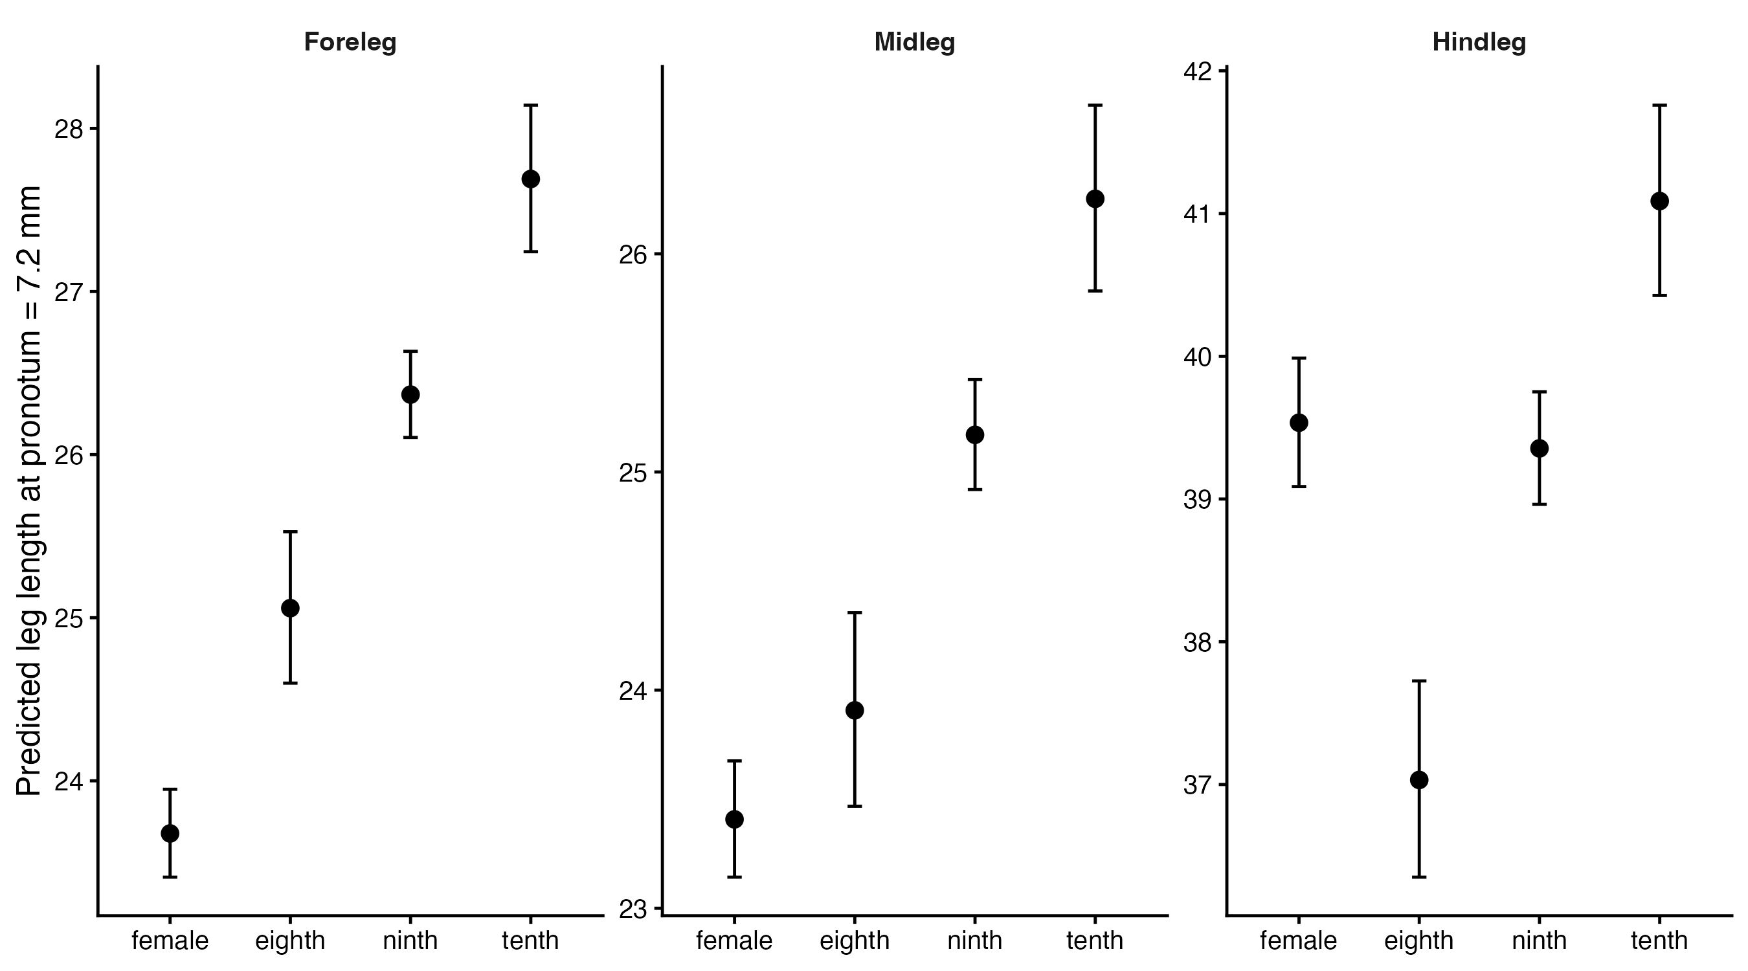
Figure 1: Size-adjusted predicted foreleg, midleg, and hindleg lengths for females and the three male morphotypes at a pronotum length of 7.2 mm. Error bars are 95% confidence intervals.

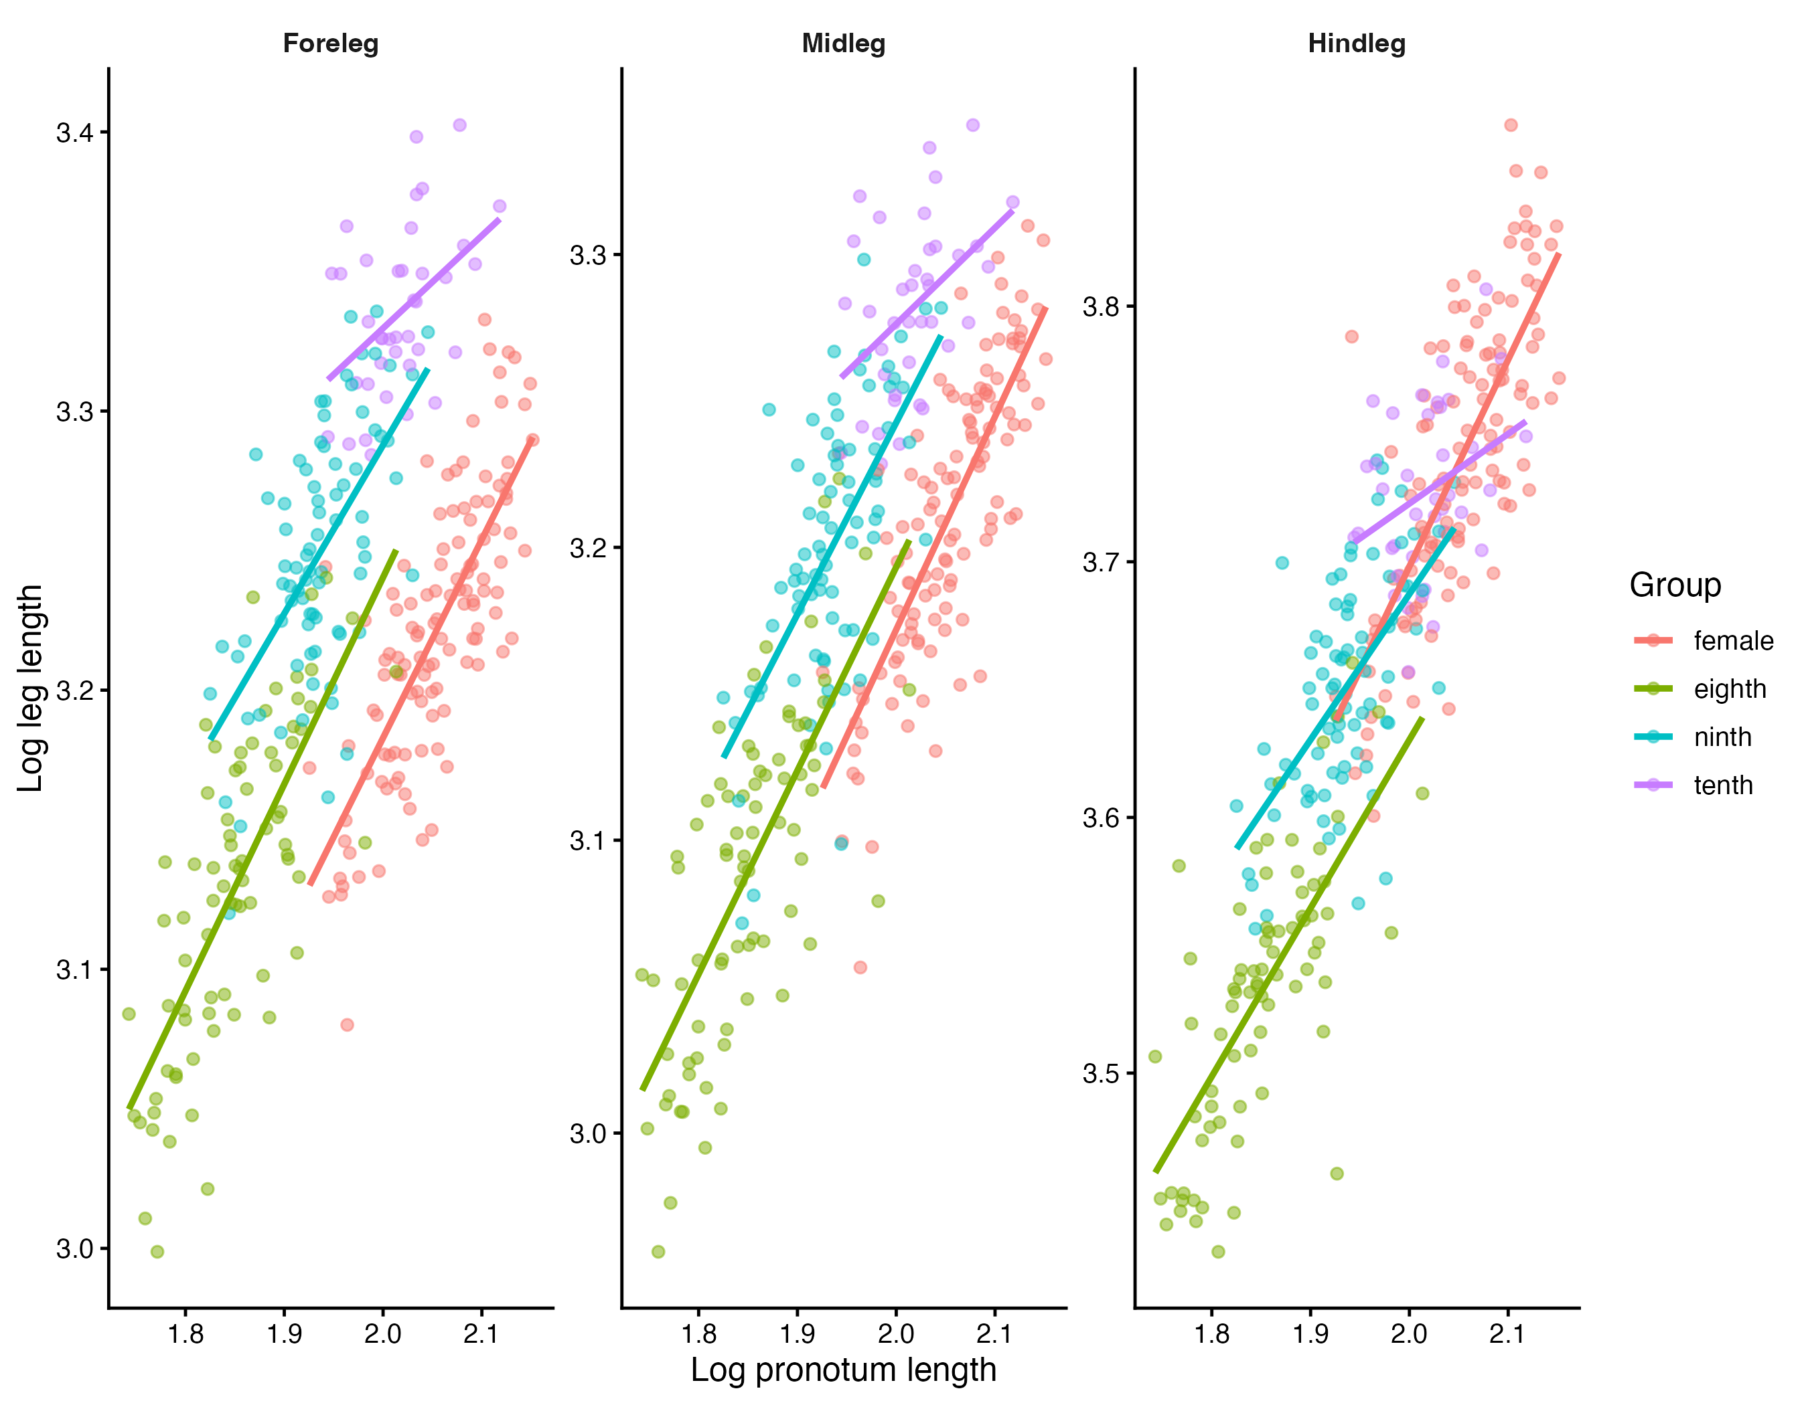
Figure 2: Log–log relationships between pronotum length and total foreleg, midleg, and hindleg length in females and the three male morphotypes.

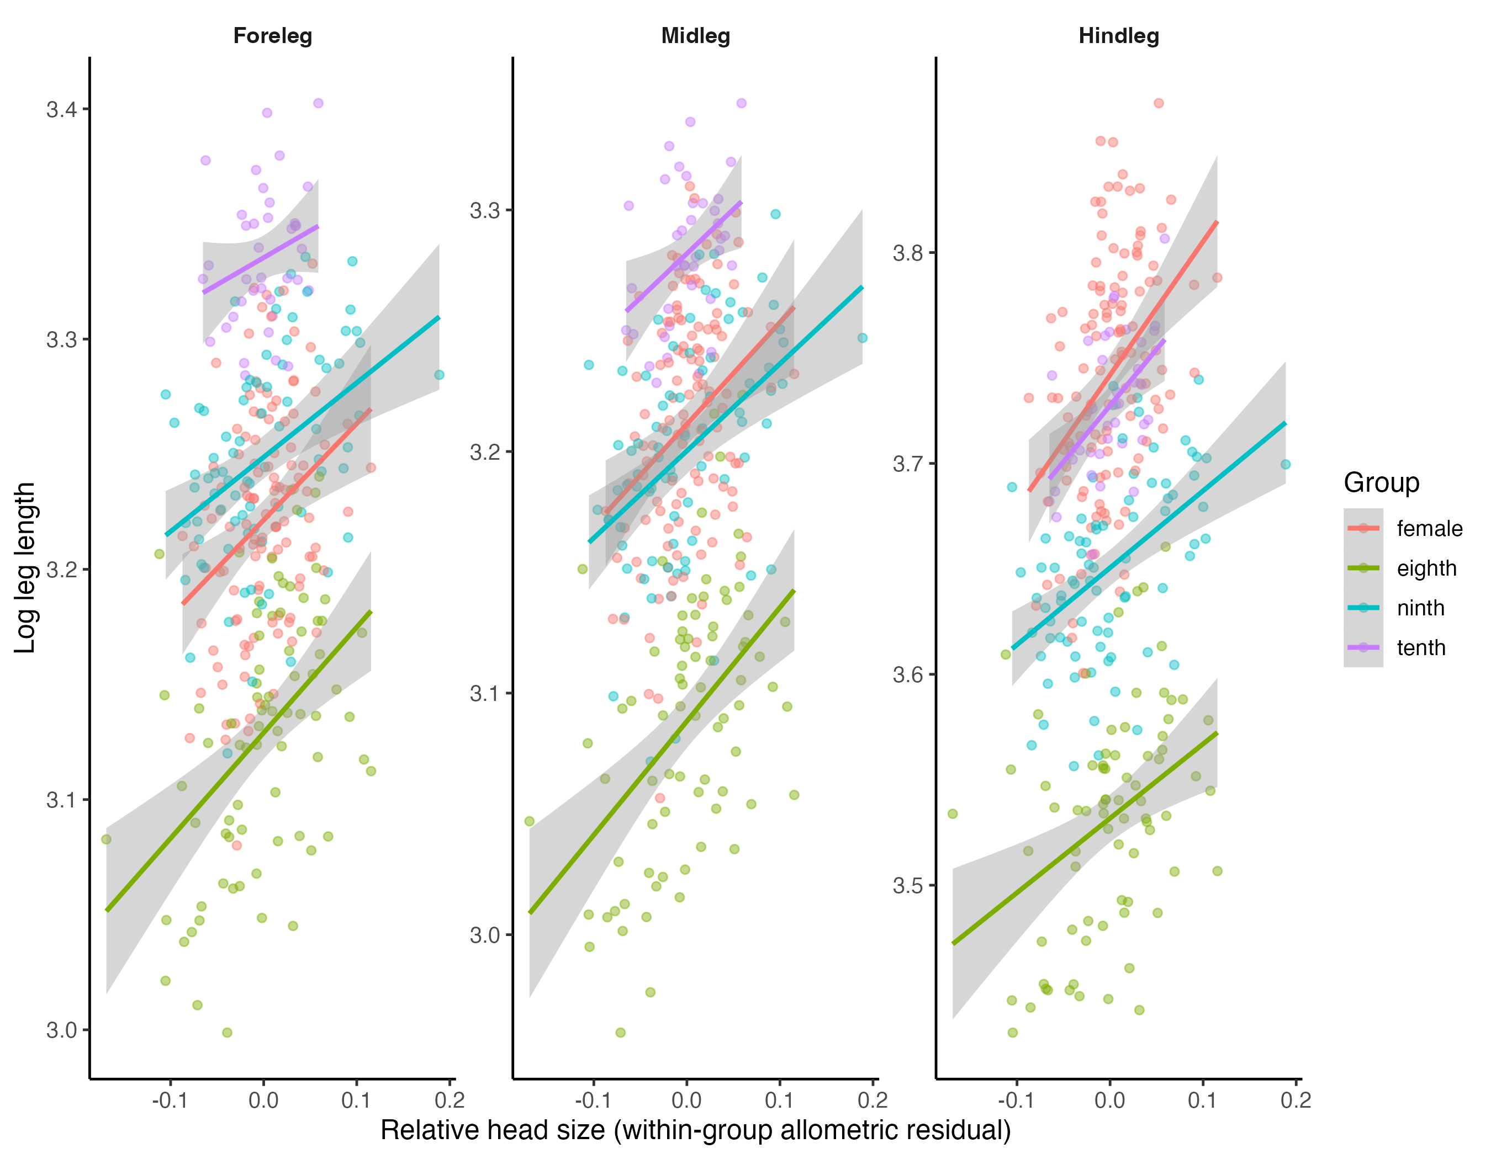
Figure 3: Relationship between relative head size (weapon size adjusted for pronotum length) and predicted leg length in females and the three male morphotypes. Lines show partial slopes after accounting for pronotum length.

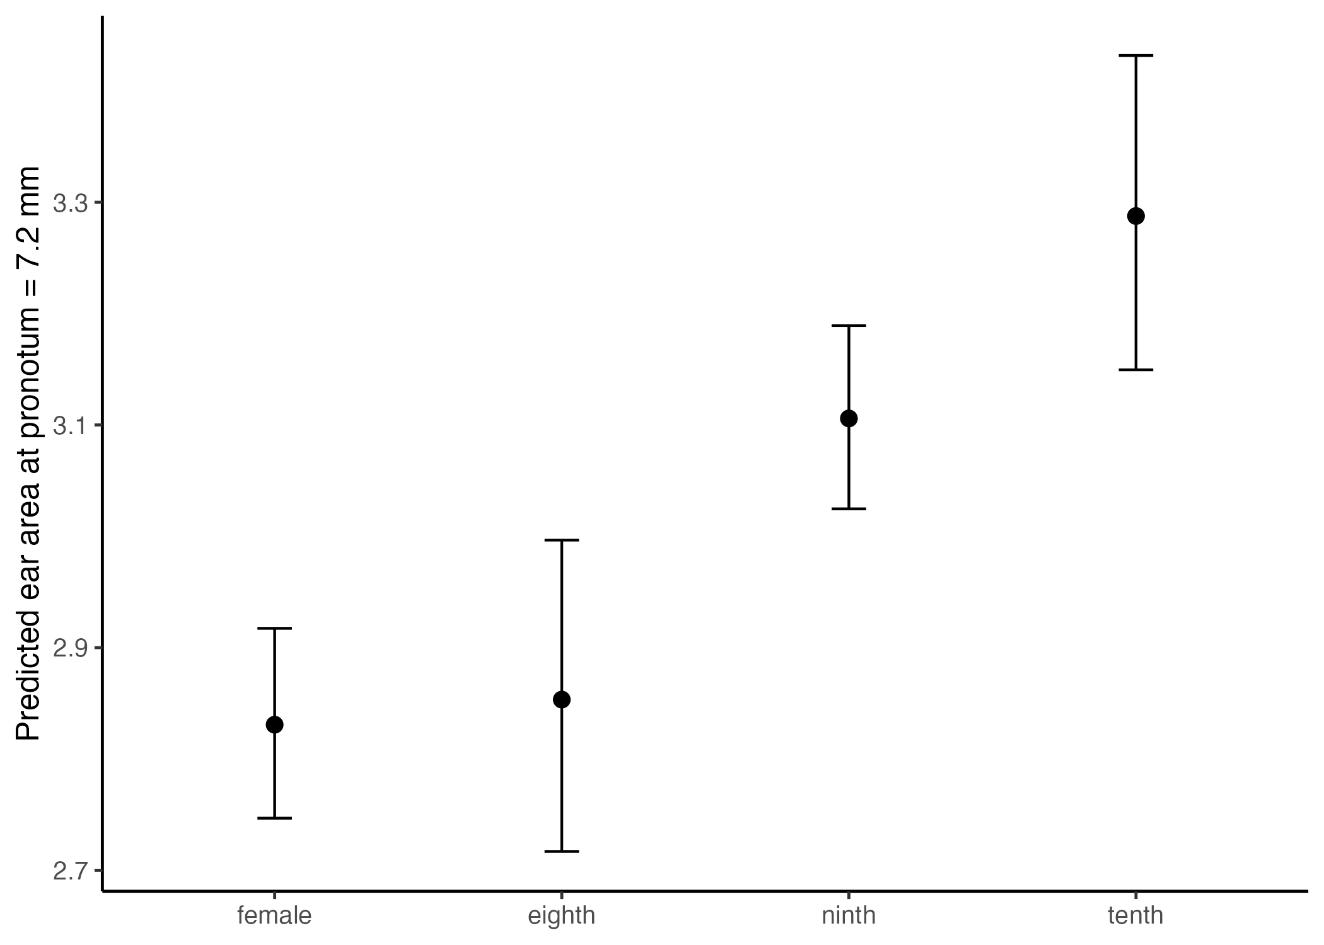
Figure 4: Predicted tympanic organ area adjusted for pronotum length in females and the three male morphotypes. Error bars are 95% confidence intervals.

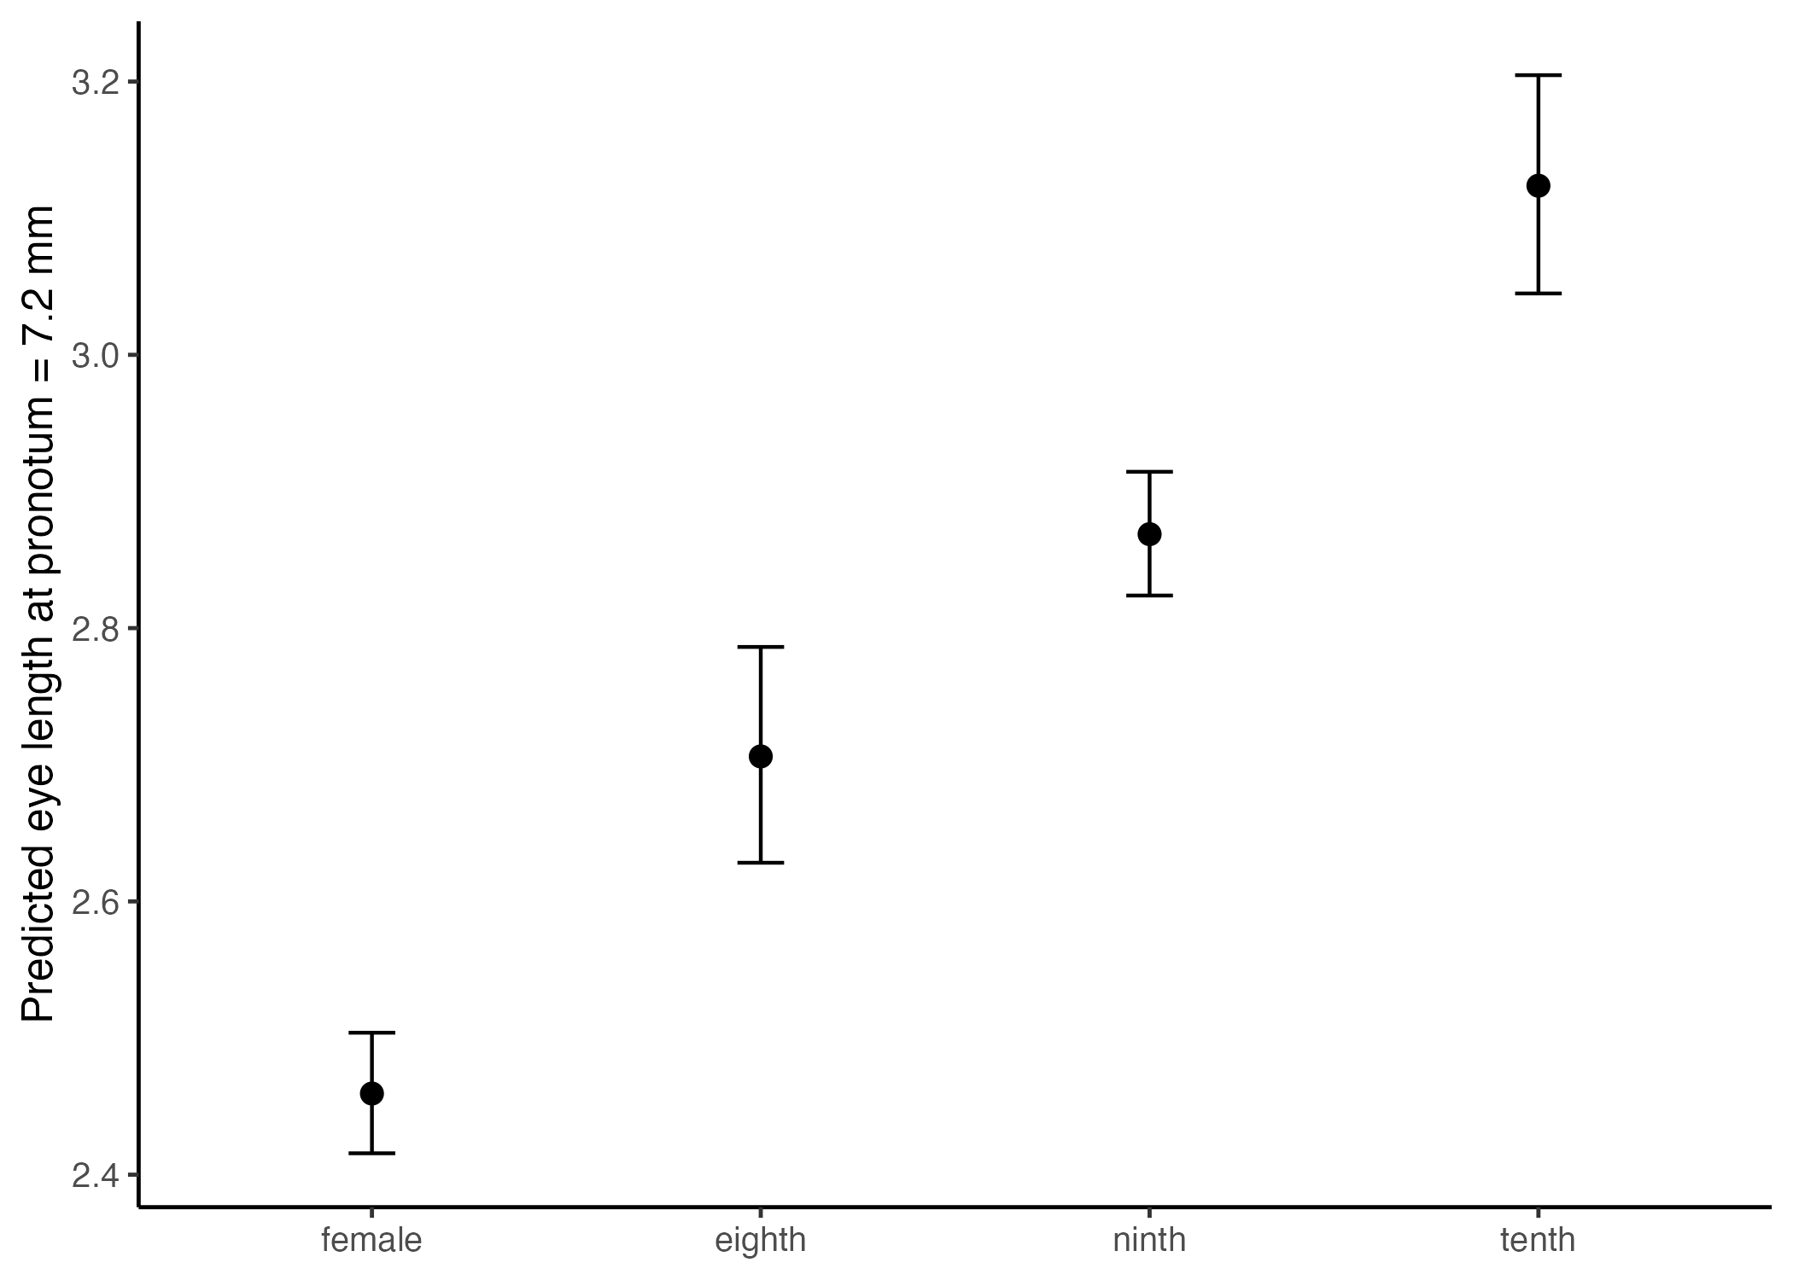
Figure 5: Predicted eye length adjusted for pronotum length in females and the three male morphotypes. Error bars are 95% confidence intervals.

Supplementary material
Supplementary Table S1. Repeatability, agreement, and measurement-round diagnostics for 11 morphological traits measured three times.
 | Repeatability, R (95% CI) |  |  | Agreement among rounds
Trait | Pooled | Morph-adjusted | Morph + round | rTEM (%) | ICC(A,1) | Max. bias (%) | Holm p
Pronotum length | 0.9950  (0.9916–0.9968) | 0.9819  (0.9690–0.9887) | 0.9942  (0.9900–0.9965) | 0.65 | 0.9951 | 1.08 | <0.001
Head length | 0.9997  (0.9995–0.9998) | 0.9960  (0.9931–0.9976) | 0.9982  (0.9968–0.9989) | 0.48 | 0.9997 | 0.70 | <0.001
Head width | 0.9991  (0.9984–0.9994) | 0.9886  (0.9810–0.9932) | 0.9937  (0.9894–0.9962) | 0.60 | 0.9991 | 0.81 | <0.001
Forefemur length | 0.9938  (0.9893–0.9962) | 0.9794  (0.9642–0.9869) | 0.9803  (0.9657–0.9876) | 0.72 | 0.9939 | 0.36 | 0.136
Foretibia length | 0.9934  (0.9887–0.9960) | 0.9817  (0.9687–0.9889) | 0.9864  (0.9765–0.9917) | 0.69 | 0.9935 | 0.66 | <0.001
Midfemur length | 0.9946  (0.9911–0.9967) | 0.9824  (0.9707–0.9893) | 0.9851  (0.9750–0.9909) | 0.61 | 0.9947 | 0.44 | 0.001
Midtibia length | 0.9959  (0.9930–0.9975) | 0.9880  (0.9790–0.9925) | 0.9880  (0.9788–0.9926) | 0.54 | 0.9959 | 0.16 | 0.705
Hindfemur length | 0.9955  (0.9924–0.9972) | 0.9835  (0.9724–0.9898) | 0.9847  (0.9742–0.9905) | 0.64 | 0.9955 | 0.39 | 0.039
Hindtibia length | 0.9868  (0.9773–0.9919) | 0.9562  (0.9249–0.9733) | 0.9596  (0.9302–0.9754) | 1.21 | 0.9868 | 0.73 | 0.039
Ear area | 0.9763  (0.9610–0.9855) | 0.9488  (0.9158–0.9691) | 0.9565  (0.9276–0.9736) | 2.57 | 0.9765 | 2.15 | 0.001
Eye length | 0.9906  (0.9841–0.9942) | 0.9717  (0.9527–0.9826) | 0.9714  (0.9519–0.9824) | 1.13 | 0.9906 | 0.23 | 0.705
Note. $R$ = individual-level ICC (95% CI from 1,000 bootstraps) for pooled, morph-adjusted, and morph + round models. rTEM = within-individual SD/mean × 100; ICC(A,1) = single-measure absolute agreement; maximum bias = largest round-pair bias (% of mean); $p$ = Holm-adjusted across traits. Estimates used 48 individuals (142–144 observations; 47–48 complete triplets). No order drift was detected (minimum Benjamini–Hochberg-adjusted $p$: 0.524 signed, 0.867 absolute).

